ALL PROJECTS INCLUDED IN SINGLE C# PROJECT FILE IN CURRENT FOLDER

EMPLOYEE CRUD OPERATION USING C#

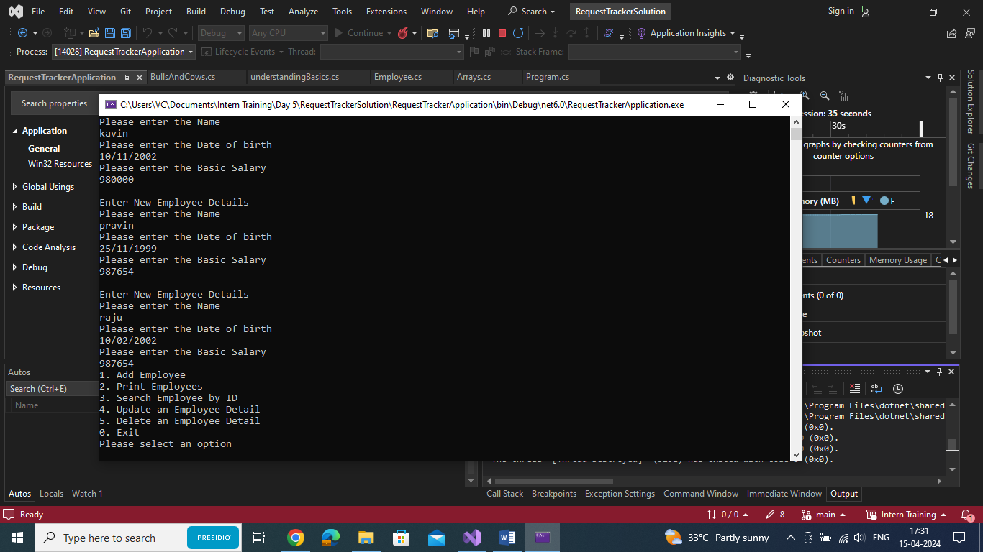

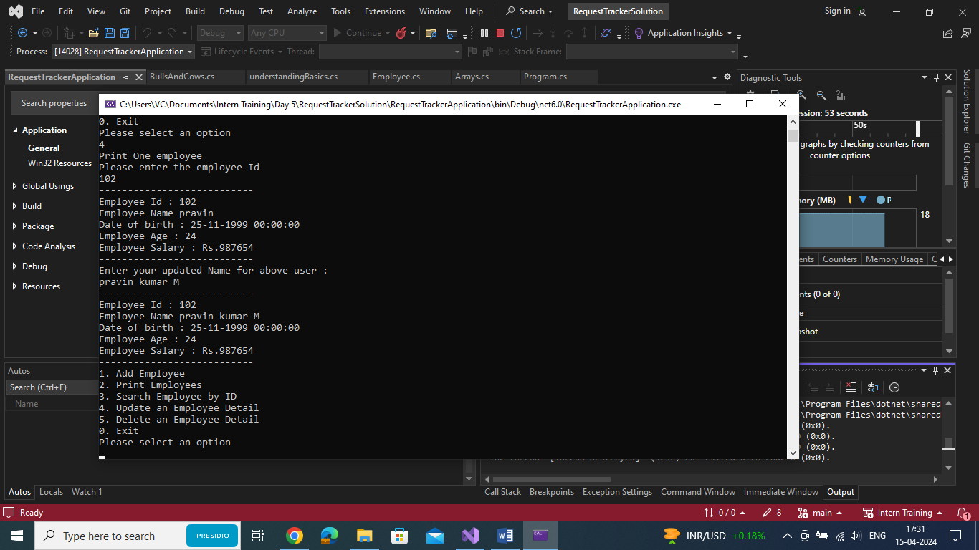

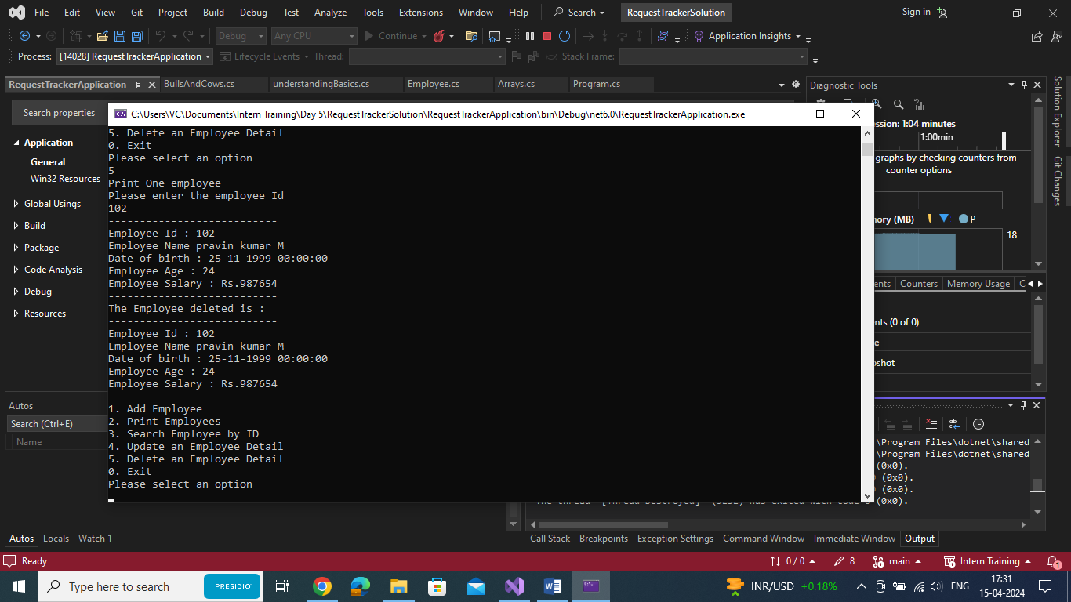

COW AND BULL PROBLEM:

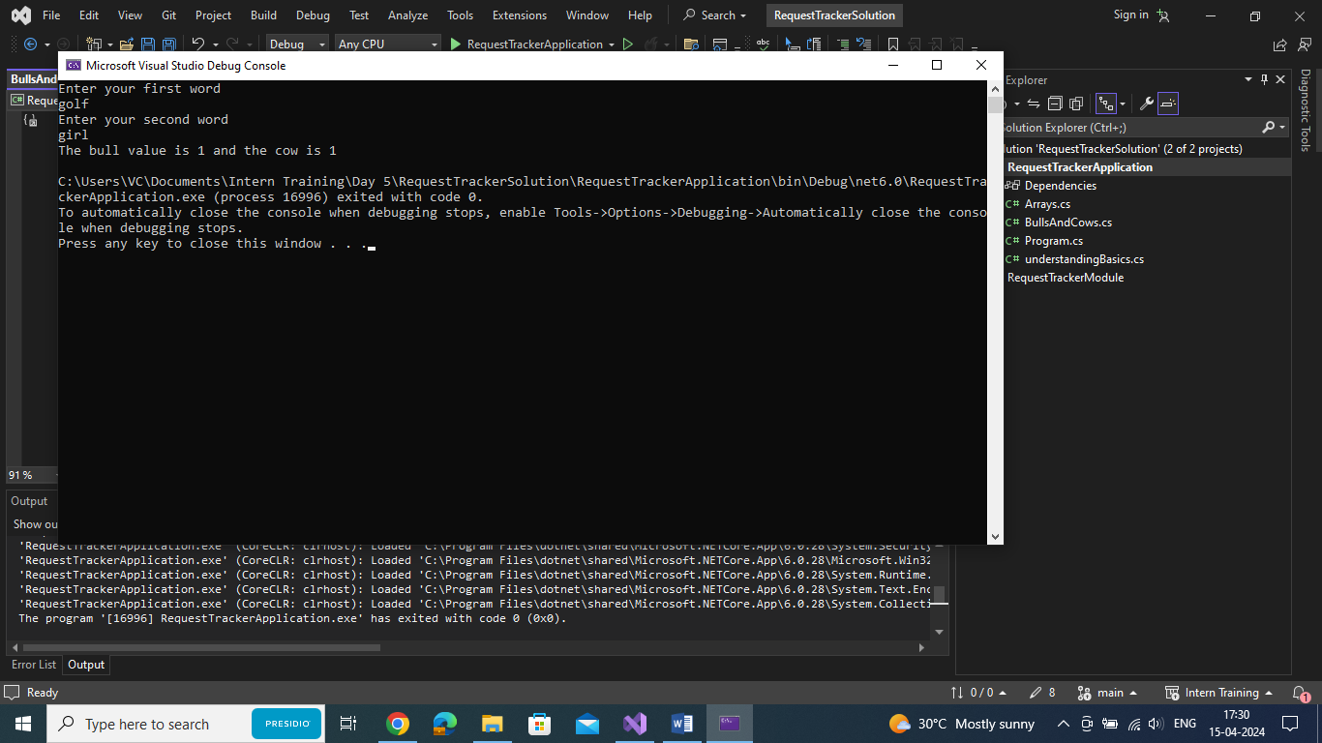

LEETCODE TRY:

